**ESS Core Members**

1. President:

Ayush Gupta

ayushgupta20@iitk.ac.in

BS-ES

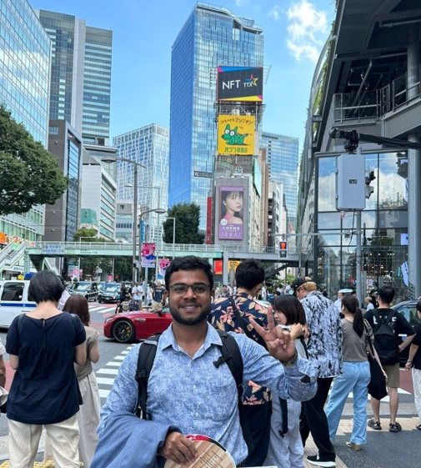

1. Vice President:

Gourab Jaiswal

gouravj22@iitk.ac.in

M.Tech

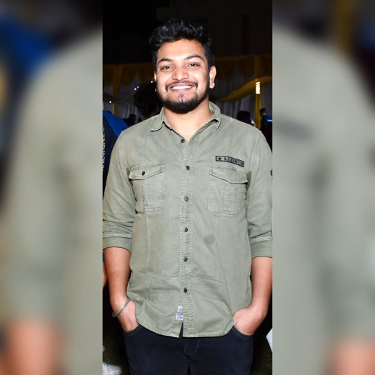

1. Secretary:

|  |  |
| --- | --- |
| Harsh Verma,  harshverma23@iitk.ac.in  M.Tech | Hitesh Arunagiri  hitesharun20@iitk.ac.in  BS Earth sciences |
| C:\Users\welcome\Downloads\IMG_20230901_192446.jpg | C:\Users\welcome\Downloads\IMG_20230822_084635.jpg |

1. Treasurer:

Keerthi Chandra Srinayak

1. Cultural Secretary:

|  |  |
| --- | --- |
| Shreya Shukla, | Swarn Raj Singh,  swarn22@iitk.ac.in  M.Tech |
|  |  |

1. Creative, media, and publicity secretary:

|  |  |
| --- | --- |
| Ayushi Nautiyal  [ayushinau23@iitk.ac.in](mailto:ayushinau23@iitk.ac.in)  M.tech | Krish Agarwal |
| C:\Users\welcome\Downloads\WhatsApp Image 2023-08-26 at 9.14.53 AM.jpeg |  |

1. Sports secretary:

|  |  |
| --- | --- |
| Sarthak Papney  sarthakp23@iitk.ac.in  PhD | Adarsh Mishra  adarshm21@iitk.ac.in  BS |
| C:\Users\welcome\Downloads\IMG_20230901_220203.jpg | C:\Users\welcome\Downloads\IMG-20230327-WA0026~2.jpg |

1. Photography:

|  |  |
| --- | --- |
| Ramswaroop Ishram  [ramswroopi23@iitk.ac.in](mailto:ramswroopi23@iitk.ac.in)  Ph.D | Arya Sorate  BS  aryass22@iitk.ac.in |
| C:\Users\welcome\Downloads\IMG_20230830_183128.jpg | C:\Users\welcome\Downloads\WhatsApp Image 2023-08-30 at 6.10.40 PM.jpeg |

1. Website Handler:

|  |  |
| --- | --- |
| Swastik Suman Behera  bswastik23@iitk.ac.in  PhD | Snehasish Haldar |
| C:\Users\welcome\Downloads\20230822_132416.jpg |  |